Trysull & Seisdon Community Garden
We’re excited to announce that plans are progressing for our new community garden, adjacent to the Village Hall in Trysull. A concept plan has been designed by Cllr Craig Smith, a regular contributor to this magazine and garden designer.

The design aims to be economic to build and create a space which can be accessed and enjoyed by different community users, such as families, the elderly or those with physical impairments, as well as those of us looking for somewhere pleasant to escape the hustle and bustle of life.

Friends of Trysull & Seisdon Community Garden Group
We are very pleased to announce that we are launching the new Friends of Trysull & Seisdon Community Garden Group. By forming a ‘friends of’ group, we’ll benefit from funding from South Staffs Council, so if you’re a keen gardener, here’s your chance to give back to the community and sign up to this new group.

You can sign up by e-mailing Chloe: seisdonandtrysullparishcouncil@gmail.com
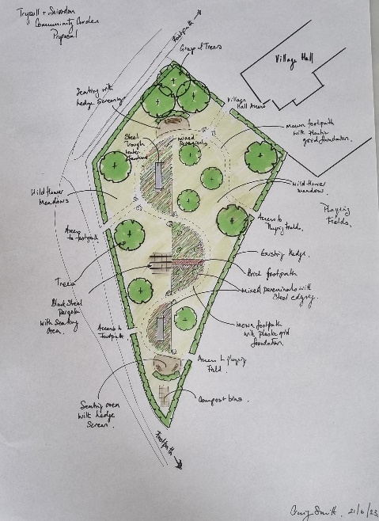

Design Concept
The design concept makes great use of the space, inviting users to access the garden from new gated entrances around the garden and to then stroll around the space on mown pathways, reinforced with a stabilising grid to make the pathways useable by wheelchairs or pushchairs.

Seating areas and benches create places for users to stop, relax and enjoy the garden space which includes semi-circular planted perennial borders.

Trees and shrubs will over time soften the garden and create visual interest as well as changes in height and texture. The planting is focused not just on visual interest but to also attract pollinating insects and other wildlife.

Sponsors and how to get involved?
The Parish Council is currently exploring what funding and support may be available to assist in building and developing this garden space. However, this project will only be realised by the generous sponsorship of local businesses and the community.

We hope that if you’re reading this you may be able to donate time, materials or money to help build this community space. Any local businesses who support this project will be listed on-site and in publicity materials as sponsors.

If you would like to become a sponsor, please contact Chloe: seisdonandtrysullparishcouncil@gmail.com

Provisional Project Plan
